**GANPAT UNIVERSITY**

**U V PATEL COLLEGE OF ENGINEERING & TECHNOLOGY**

**DEPARTMENT OF COMPUTER SCIENCE AND ENGINEERING**

**B.TECH 1st SEMESTER SUBJECT**

**Name: Mansi Bagadia Stream:BDA**

**Subject: ESFP-I**

**Date: 27/8/14**

Assignment-1

GOAL:

1. Write a program to print ASCII values of all backslash characters and white space on screen in following format :

The ASCII value of ‘\t’ is : 9

(Hint : you can verify your ASCII values with the help of a table for ASCII values from text book)

2. Explain different data types available in C.

3. Explain about C Tokens in brief.

4. Explain about backslash characters in C.

**ANSWERS**

**1.**

**#include<stdio.h>**

**#include<conio.h>**

**void main()**

**{**

**int ch,ch1,ch2,ch3,ch4,ch5,ch6,ch7,ch8,ch9,ch10,ch11;**

**ch='\a';**

**ch1='\b';**

**ch2='\f';**

**ch3='\n';**

**ch4='\r';**

**ch5='\t';**

**ch6='\v';**

**ch7='\'';**

**ch8='\"';**

**ch9='\?';**

**ch10='\\';**

**ch11='10';**

**clrscr();**

**printf("The ASCII value of'\\a'is:%d\n",ch);**

**printf("The ASCII value of'\\b'is:%d\n",ch1);**

**printf("The ASCII value of'\\f'is:%d\n",ch2);**

**printf("The ASCII value of'\\n'is:%d\n",ch3);**

**printf("The ASCII value of'\\r'is:%d\n",ch4);**

**printf("The ASCII value of'\\t'is:%d\n",ch5);**

**printf("The ASCII value of'\\v'is:%d\n",ch6);**

**printf("The ASCII value of'\\''is:%d\n",ch7);**

**printf("The ASCII value of'\\'is:%d\n",ch8);**

**printf("The ASCII value of'\\?'is:%d\n",ch9);**

**printf("The ASCII value of'\\\'is:%d\n",ch10);**

**printf("The ASCII value of'10'is:%d\n",ch11);**

**getch();**

**}**

**OUTPUT**

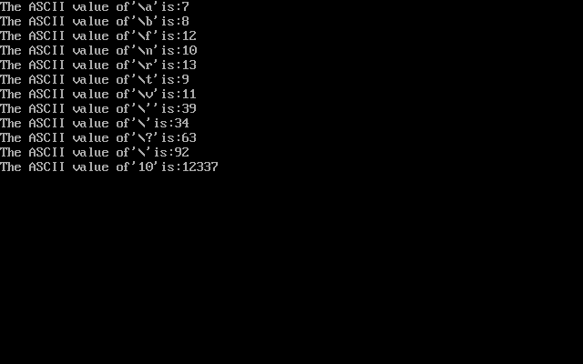

**2.**

C language is rich in its data type. A program usually contains different types of data types (integer, float, character etc.) and need to store the values being used in the program. A C programmer has to employ proper data type as per there requirements.

C has different data types for different types of data and are classified as:

1. Primary Data Types

2. Secondary Data Types

* *Primary Data Types:*
* Integer Data Types:

Integers are whole numbers with a range of values, range of values are machine supported. Generally an integer occupies 16 bits memory space and its value range limited to -32768 to +32767 (that is, -215 to +215-1). A signed integer use one bit for storing sign and rest 15 bits for number. To control the range of numbers and storage space, C has three classes of integer storage namely short int, int and long int. All three data types have signed and unsigned forms. A short int requires half the amount of storage than normal integer. Unlike signed integer, unsigned integers are always positive and use all the bits for the magnitude of the number. Therefore, the range of an unsigned integer will be from 0 to 65535. The long integers are used to declare a longer range of values and it occupies 4 bytes of storage space.

* Floating Point Data Types:

The float (or real)data type is used to store in 32 bits with 6 digits of precision. Floating point numbers are denoted by the keyword float. When the accuracy of the floating point number is insufficient, we can use the double to define the number. The double is same as float

* Character Data Type:

Character type variable can hold a single character and are declared by using the keyword char. As there are singed and unsigned int (either short or long), in the same way there are signed and unsigned chars; both occupy 1 byte each, but having different ranges. Unsigned characters have

values between 0 and 255, signed characters have values from –128 to 127.

* Void Type:

The void type has no values therefore we cannot declare it as variable as we did in case of integer and float. The void data type is usually used with function to specify its type.

**3.**

**In a C program , the smallest individual units are called C tokens.**

**C program are written using these tokens and the syntax of languages**

**In C program, it has Six types of tokens which are namely classified as follows.**

* **Keywords**
* **Identifiers**
* **Constants**
* **Strings**
* **Operators**
* **Special Symbols**

**4.**

**C supports some special backslash character constants that are used in output functions.**

**Each character represents one character although they consist of two characters.**

**These character combinations are called escape sequences.**

* **\a : audible alert**
* **\b: backspace**
* **\t: horizontal tab are some of the backslash character constant**